**Module  A.1:Simon Game Icebreaker**

**Level 0: Play the Simon game**

1. My highest score was 5
2. The highest score within our group was 11
3. It is just a challenge to get the highest score among your friends, and you just want to keep going on.
4. Simon is similar to some of the modern computer games because it has levels,

1. The user pushes the buttons in the order which the Simon game tells you to
2. The user has to input the order which the Simon game gives, if the user gets it right then the Simon game will move on to the next pattern and move up a level, and if the user gets the order wrong then the game will stop.
3. There are a total of two ways to play the game, one is solo. In the solo mode you simply hit the red button and play by yourself. The second mode is pass, this is where you play in a group and pass the gamer on, in order to play this mode you have to press the green button.
4. When the player inputs the wrong button the games makes a sound the button which was incorrect is the only one which is lit. Along with the on the little screen you will see a “X” indicating the player hit the wrong button

**Level 1: Simon history**

1. Baer, Ralph H. created the Simon game
2. Simon was based on an Atari game which was called “Touch Me”
3. Atari pong was the first ever video game system
4. Space invaders and pong
5. Nintendo 360
6. The games now have better graphics, and better control and the controls are now more complex as the controller changes (e.g. A joystick compared to a ps4 controller )
7. The New games which come out now are carrying on the story, which makes the similar. The only difference is how the games look and feel.

**Level 2:Input-Output Analysis**

**1.**

|  |  |  |
| --- | --- | --- |
| **Object** | **Action** | **Description** |
| **Red Button** | **Touch** | **Starts Solo mode** |
| **Green Button** | **Touch** | **Start “Pass it mode”** |
| **Green Button** | **Touch** | **Records a step in a pattern** |
| **Red button** | **Touch** | **Records a step in a pattern** |
| **Blue button** | **Touch** | **Records  a step in a pattern** |
| **Yellow Button** | **Touch** | **Records  a step in a pattern** |
| **Small green button** | **Push** | **Starts the Game** |

**2.**

|  |  |  |
| --- | --- | --- |
| **Object** | **Action** | **Description** |
| **Red light** | **Flash** | **Indicates step in pattern** |
| **Yellow light** | **Flash** | **indicates steps in pattern** |
| **Green light** | **Flash** | **indicates steps in pattern** |
| **Blue light** | **Flash** | **Indicates steps in pattern** |
| **Red sound** | **Tone** | **indicates steps in pattern** |
| **Yellow sound** | **Tone** | **indicates steps in pattern** |
| **Green sound** | **Tone** | **indicates steps in pattern** |
| **Blue Sound** | **Tone** | **indicates steps in pattern** |

**3.**

|  |  |  |
| --- | --- | --- |
| **Object** | **output action** | **process connection** |
| **red button** | **red light** | **flashes when button is pushed (indicates step of pattern)** |
| **blue button** | **blue light** | **flashes when button is pushed ( indicates step of pattern)** |
| **green button** | **green light** | **flashes when button is pushed (indicates step of pattern)** |
| **yellow button** | **yellow light** | **flashes when button is pushed (indicates step of pattern)** |
| **small green button** | **Simon game logo countdown** | **the Simon game logo appears on little screen to indicate the game is starting** |
| **wrong red button** | **Only red light/A Boop sound/ “X” shows on smaller screen** | **All other lights are off, while wrong red light stays on** |
| **wrong blue button** | **Only a blue light/A boop sound/ “X” Shows on smaller screen** | **All other lights are off, while wrong blue light stays on** |
| **Wrong Yellow light** | **Only Yellow light stays on/A boop sound/ “X” shows on small screen** | **All other lights are off while wrong yellow light stays on** |
| **Wrong Green light** | **Only green light stays on/A boop Sound/ “X” shows on smaller screen** | **All other lights are off while wrong green light stays on** |

**Level 3 : Flowchart conventions**

1. **Basic symbols**

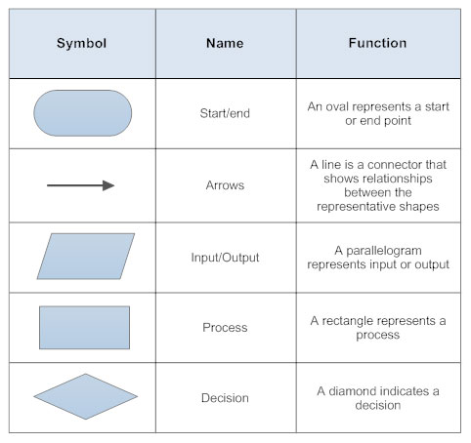

1. **Flowchart with each symbol used twice**

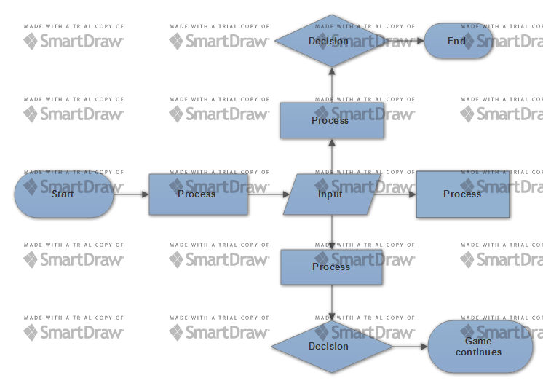

1. **3 tone flowchart** 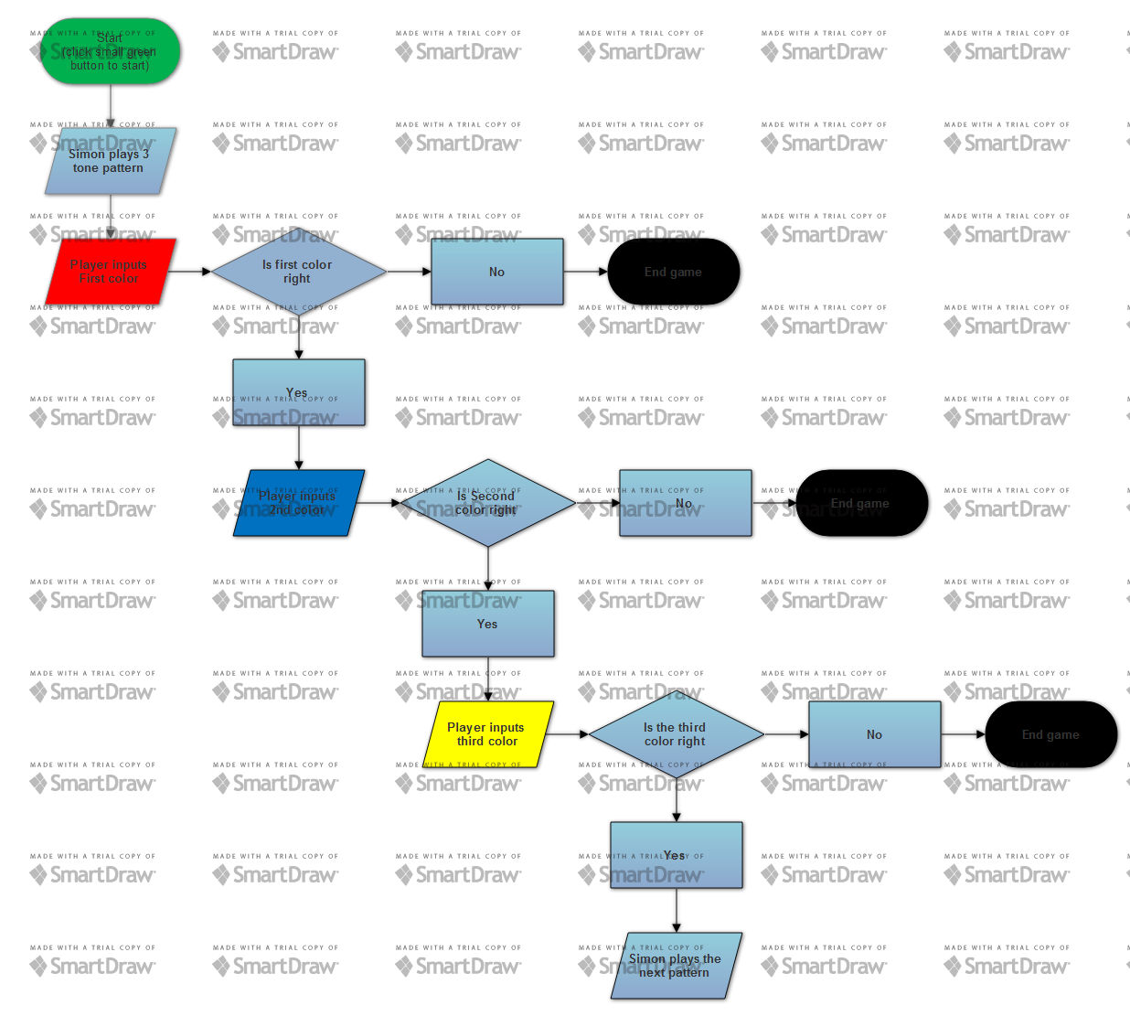
2. **Chart for whole Simon game**

